EXPERIMENT 1
#include<stdio.h>
#include<unistd.h>
int main(){
printf("Process ID: %d\n", getpid() ); printf("ParentProcess ID: %d\n", getpid() );
return 0;
}
OUTPUT:
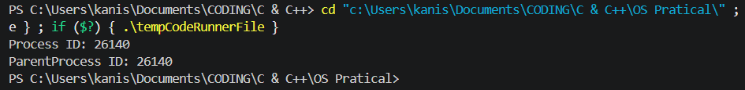

EXPERIMENT 2
#include <stdio.h>
#include <stdlib.h>
int main()
{
FILE *fptr1, *fptr2; char
filename[100], c;
printf("Enter the filename to open for reading \n");
scanf("%s", filename);
fptr1 = fopen(filename, "r");if
(fptr1 == NULL)
{
printf("Cannot open file %s \n", filename);
exit(0);
}
printf("Enter the filename to open for writing \n");
scanf("%s", filename);
fptr2 = fopen(filename, "w");if
(fptr2 == NULL)
{
printf("Cannot open file %s \n", filename);
exit(0);
}
c = fgetc(fptr1);
while (c != EOF)
{
fputc(c, fptr2); c
= fgetc(fptr1);
}
printf("\nContents copied to %s", filename);
fclose(fptr1);
fclose(fptr2);
return 0;
}
OUTPUT:
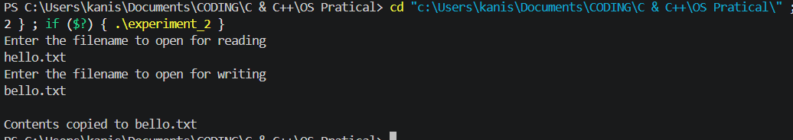

EXPERIMENT 3

HANDLE full_slots;

// Producer Thread Routine
DWORD WINAPI producer(LPVOID param) {
for (int i = 1; i <= TOTAL_ITEMS; i++) {
// 1. Wait until an empty slot is available (decrement empty_slots)
WaitForSingleObject(empty_slots, INFINITE);

// 2. Lock buffer (enter critical section)
WaitForSingleObject(mutex, INFINITE);

// 3. Add item to buffer
buffer[in] = i;
printf("[Producer] Inserted item %d at index %d\n", i, in);
in = (in + 1) % BUFFER_SIZE;

// 4. Unlock buffer (leave critical section)
ReleaseMutex(mutex);

// 5. Signal that an item is available (increment full_slots)
ReleaseSemaphore(full_slots, 1, NULL);

Sleep(150); // Pause 150ms to simulate production time
}
return 0;
}

// Consumer Thread Routine
DWORD WINAPI consumer(LPVOID param) {
for (int i = 1; i <= TOTAL_ITEMS; i++) {
// 1. Wait until a produced item is available (decrement full_slots)
WaitForSingleObject(full_slots, INFINITE);

// 2. Lock buffer (enter critical section)
WaitForSingleObject(mutex, INFINITE);

// 3. Remove item from buffer
int item = buffer[out];
printf(" [Consumer] Consumed item %d from index %d\n", item, out);
out = (out + 1) % BUFFER_SIZE;

// 4. Unlock buffer (leave critical section)
ReleaseMutex(mutex);

// 5. Signal that an empty slot is freed (increment empty_slots)
ReleaseSemaphore(empty_slots, 1, NULL);

Sleep(300); // Pause 300ms to simulate consumption time
}
return 0;
}

int main() {
HANDLE producer_thread;
HANDLE consumer_thread;

// Create a Mutex: initially unowned (FALSE)
mutex = CreateMutex(NULL, FALSE, NULL);

// Create Counting Semaphores:
// empty_slots: initial count = BUFFER_SIZE, max count = BUFFER_SIZE
empty_slots = CreateSemaphore(NULL, BUFFER_SIZE, BUFFER_SIZE, NULL);
// full_slots: initial count = 0, max count = BUFFER_SIZE
full_slots = CreateSemaphore(NULL, 0, BUFFER_SIZE, NULL);

// Verify handles were successfully created
if (mutex == NULL || empty_slots == NULL || full_slots == NULL) {
printf("Error: Synchronization handle creation failed.\n");
return 1;
}

// Launch Producer and Consumer threads
producer_thread = CreateThread(NULL, 0, producer, NULL, 0, NULL);
consumer_thread = CreateThread(NULL, 0, consumer, NULL, 0, NULL);

// Wait for both threads to finish execution
HANDLE threads[2] = { producer_thread, consumer_thread };
WaitForMultipleObjects(2, threads, TRUE, INFINITE);

// Clean up handles to prevent resource leaks
CloseHandle(producer_thread);
CloseHandle(consumer_thread);
CloseHandle(mutex);
CloseHandle(empty_slots);
CloseHandle(full_slots);

printf("\nExecution completed successfully without race conditions.\n");
return 0;
}

OUTPUT:
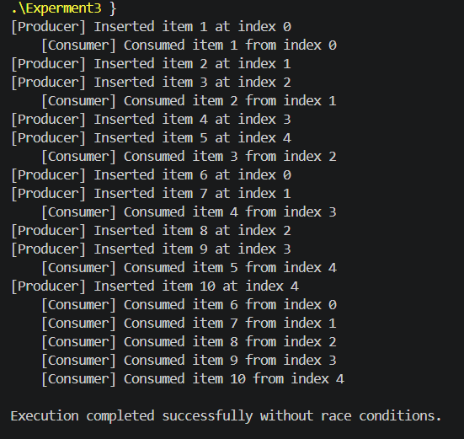
EXPERIMENT 4
import java.io.*;
import java.net.*;

public class Experiment4server {
public static void main(String[] args) {
int port = 9090;
try (DatagramSocket serverSocket = new DatagramSocket(port)) {
System.out.println("UDP Server is ready to receive on port " + port + "...");

byte[] receiveBuffer = new byte[1024];
DatagramPacket receivePacket = new DatagramPacket(receiveBuffer, receiveBuffer.length);

// Receive datagram from client
serverSocket.receive(receivePacket);
String message = new String(receivePacket.getData(), 0, receivePacket.getLength());
InetAddress clientAddress = receivePacket.getAddress();
int clientPort = receivePacket.getPort();

System.out.println("Received message from " + clientAddress + ":" + clientPort + " -> " + message);

// Send response back to client
String responseStr = "Hello from UDP Server! Datagram received.";
byte[] sendBuffer = responseStr.getBytes();
DatagramPacket sendPacket = new DatagramPacket(sendBuffer, sendBuffer.length, clientAddress, clientPort);

serverSocket.send(sendPacket);

} catch (IOException e) {
e.printStackTrace();
}
}
}

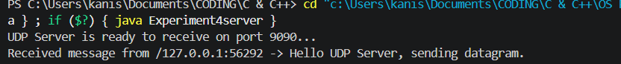

EXPERIMENT 5
import java.util.LinkedList;
import java.util.Queue;

public class Experiment5 {

// A shared buffer where items are produced and consumed
static class SharedBuffer {
private final Queue<Integer> queue = new LinkedList<>();
private final int capacity;

public SharedBuffer(int capacity) {
this.capacity = capacity;
}

// Producer adds an item to the buffer
public synchronized void produce(int value) throws InterruptedException {
while (queue.size() == capacity) {
System.out.println("Buffer is full! Producer is waiting...");
wait(); // Wait until space becomes available
}

queue.add(value);
System.out.println("Produced: " + value + " | Buffer size: " + queue.size());

// Notify waiting consumer threads that an item is available
notifyAll();
}

// Consumer removes an item from the buffer
public synchronized int consume() throws InterruptedException {
while (queue.isEmpty()) {
System.out.println("Buffer is empty! Consumer is waiting...");
wait(); // Wait until an item is produced
}

int value = queue.poll();
System.out.println("Consumed ---> " + value + " | Buffer size: " + queue.size());

// Notify waiting producer threads that space is available
notifyAll();

return value;
}
}

// Producer Task
static class Producer implements Runnable {
private final SharedBuffer buffer;

public Producer(SharedBuffer buffer) {
this.buffer = buffer;
}

@Override
public void run() {
try {
for (int i = 1; i <= 5; i++) {
buffer.produce(i);
Thread.sleep(500); // Simulate time taken to produce an item
}
} catch (InterruptedException e) {
Thread.currentThread().interrupt();
System.out.println("Producer was interrupted.");
}
}
}

// Consumer Task
static class Consumer implements Runnable {
private final SharedBuffer buffer;

public Consumer(SharedBuffer buffer) {
this.buffer = buffer;
}

@Override
public void run() {
try {
for (int i = 1; i <= 5; i++) {
buffer.consume();
Thread.sleep(800); // Simulate time taken to consume an item
}
} catch (InterruptedException e) {
Thread.currentThread().interrupt();
System.out.println("Consumer was interrupted.");
}
}
}

// Main Method to Run the Simulation
public static void main(String[] args) {
System.out.println("=== Multithreading Started ===");

// Create a shared buffer with a maximum capacity of 3
SharedBuffer buffer = new SharedBuffer(3);

// Create Producer and Consumer threads
Thread producerThread = new Thread(new Producer(buffer), "Producer-Thread");
Thread consumerThread = new Thread(new Consumer(buffer), "Consumer-Thread");

// Start the threads
producerThread.start();
consumerThread.start();

try {
// Wait for both threads to finish execution
producerThread.join();
consumerThread.join();
} catch (InterruptedException e) {
System.out.println("Main thread interrupted.");
}

System.out.println("=== Multithreading Completed ===");
}
}
OUTPUT:
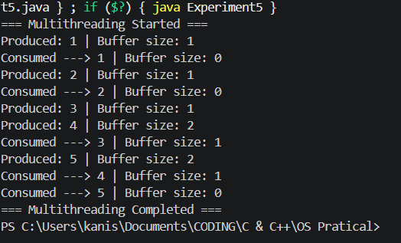

EXPERIMENT 6
#include <stdio.h>
void findWaitingTime(int processes[], int n, int bt[], int wt[]) {
wt[0] = 0;
for (int i = 1; i < n; i++)
wt[i] = bt[i - 1] + wt[i - 1];
}

void findTurnAroundTime(int processes[], int n, int bt[], int wt[], int tat[]) {
for (int i = 0; i < n; i++)
tat[i] = bt[i] + wt[i];
}

void findAverageTime(int processes[], int n, int bt[]) {
int wt[n], tat[n], total_wt = 0, total_tat = 0;

findWaitingTime(processes, n, bt, wt);
findTurnAroundTime(processes, n, bt, wt, tat);

printf("Processes Burst Time Waiting Time Turnaround Time\n");
for (int i = 0; i < n; i++) {
total_wt = total_wt + wt[i];
total_tat = total_tat + tat[i];
printf(" %d %d %d %d\n", i + 1, bt[i], wt[i], tat[i]);
}

printf("Average waiting time = %.2f\n", (float)total_wt / (float)n);
printf("Average turnaround time = %.2f\n", (float)total_tat / (float)n);
}

int main() {
int processes[] = {1, 2, 3};
int n = sizeof(processes) / sizeof(processes[0]);
int burst_time[] = {10, 5, 8};

findAverageTime(processes, n, burst_time);
return 0;
}
OUTPUT:
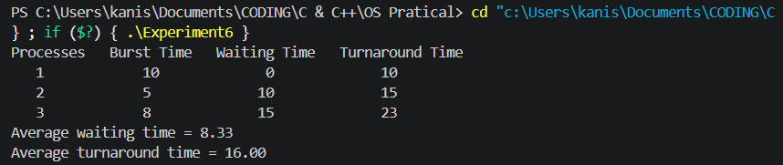
EXPERIMENT 7
#include <stdio.h>

int main() {
int p[20], bt[20], wt[20], tat[20], i, j, n, total = 0, pos, temp;

printf("Enter number of processes: ");
scanf("%d", &n);

printf("\nEnter Burst Time:\n");
for (i = 0; i < n; i++) {
p[i] = i + 1;
printf("P%d: ", i + 1);
scanf("%d", &bt[i]);
}

// Sorting burst time in ascending order using selection sort
for (i = 0; i < n; i++) {
pos = i;
for (j = i + 1; j < n; j++) {
if (bt[j] < bt[pos])
pos = j;
}

temp = bt[i];
bt[i] = bt[pos];
bt[pos] = temp;

temp = p[i];
p[i] = p[pos];
p[pos] = temp;
}

wt[0] = 0; // Waiting time for first process is zero

for (i = 1; i < n; i++) {
wt[i] = 0;
for (j = 0; j < i; j++)
wt[i] += bt[j];
total += wt[i];
}

float avg_wt = (float)total / n;
total = 0;

printf("\nProcess\t Burst Time\t Waiting Time\tTurnaround Time");
for (i = 0; i < n; i++) {
tat[i] = bt[i] + wt[i];
total += tat[i];
printf("\nP%d\t\t%d\t\t%d\t\t%d", p[i], bt[i], wt[i], tat[i]);
}

float avg_tat = (float)total / n;
printf("\n\nAverage Waiting Time = %.2f", avg_wt);
printf("\nAverage Turnaround Time = %.2f\n", avg_tat);

return 0;
}

OUTPUT:
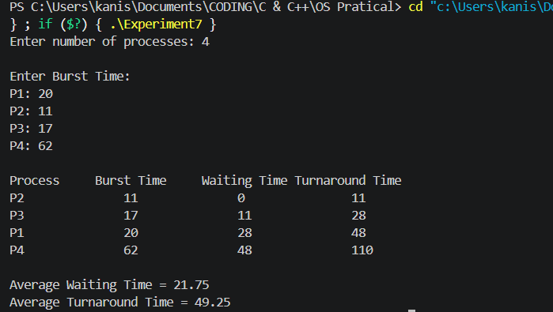

EXPERIMENT 8
#include <stdio.h>

int main() {
int p[20], bt[20], pri[20], wt[20], tat[20], i, j, n, total = 0, pos, temp;

printf("Enter Total Number of Processes: ");
scanf("%d", &n);

printf("\nEnter Burst Time and Priority\n");
for (i = 0; i < n; i++) {
p[i] = i + 1;
printf("P[%d] Burst Time: ", i + 1);
scanf("%d", &bt[i]);
printf("P[%d] Priority: ", i + 1);
scanf("%d", &pri[i]);
}

// Sorting processes by priority (ascending order: lower number = higher priority)
for (i = 0; i < n; i++) {
pos = i;
for (j = i + 1; j < n; j++) {
if (pri[j] < pri[pos])
pos = j;
}

temp = pri[i];
pri[i] = pri[pos];
pri[pos] = temp;

temp = bt[i];
bt[i] = bt[pos];
bt[pos] = temp;

temp = p[i];
p[i] = p[pos];
p[pos] = temp;
}

wt[0] = 0; // Waiting time for first process is zero

for (i = 1; i < n; i++) {
wt[i] = 0;
for (j = 0; j < i; j++)
wt[i] += bt[j];
total += wt[i];
}

float avg_wt = (float)total / n;
total = 0;

printf("\nProcess\t Priority\tBurst Time\tWaiting Time\tTurnaround Time");
for (i = 0; i < n; i++) {
tat[i] = bt[i] + wt[i];
total += tat[i];
printf("\nP[%d]\t\t%d\t\t%d\t\t%d\t\t%d", p[i], pri[i], bt[i], wt[i], tat[i]);
}

float avg_tat = (float)total / n;
printf("\n\nAverage Waiting Time = %.2f", avg_wt);
printf("\nAverage Turnaround Time = %.2f\n", avg_tat);

return 0;
}

OUTPUT:
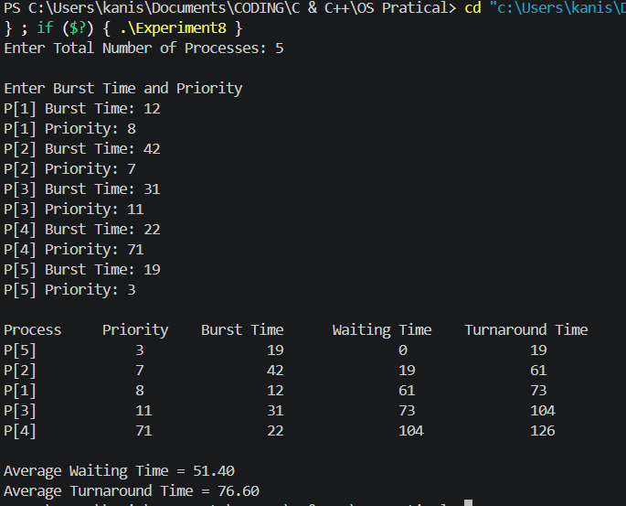

EXPERIMENT 9
#include <stdio.h>

int main() {
int i, n, sum = 0, count = 0, y, quant, wt = 0, tat = 0, at[10], bt[10], temp[10];
float avg_wt, avg_tat;
printf("Total number of processes in system: ");
scanf("%d", &n);
y = n;
for (i = 0; i < n; i++) {
printf("\nEnter the Burst Time of Process[%d]: ", i + 1);
scanf("%d", &bt[i]);
at[i] = 0; // Assuming arrival time is 0 for simplicity
temp[i] = bt[i];
}

printf("Enter the Time Quantum: ");
scanf("%d", &quant);

printf("\nProcess No \t Burst Time \t TAT \t Waiting Time");
for (sum = 0, i = 0; y != 0;) {
if (temp[i] <= quant && temp[i] > 0) {
sum += temp[i];
temp[i] = 0;
count = 1;
} else if (temp[i] > 0) {
temp[i] -= quant;
sum += quant;
}
if (temp[i] == 0 && count == 1) {
y--;
printf("\nProcess[%d] \t\t %d \t\t %d \t\t %d", i + 1, bt[i], sum - at[i], sum - at[i] - bt[i]);
wt += sum - at[i] - bt[i];
tat += sum - at[i];
count = 0;
}
if (i == n - 1)
i = 0;
else if (at[i + 1] <= sum)
i++;
else
i = 0;
}

avg_wt = (float)wt / n;
avg_tat = (float)tat / n;
printf("\n\nAverage Waiting Time: %.2f", avg_wt);
printf("\nAverage Turnaround Time: %.2f\n", avg_tat);

return 0;
}

OUTPUT:
